Themenblock 13: INFORMATION & COMM. TECHNOLOGY

CATEGORY A: CONTRASTING IMAGES

TASK SET A1: The 3am Scroll

Part 1 – Individual Long Turn

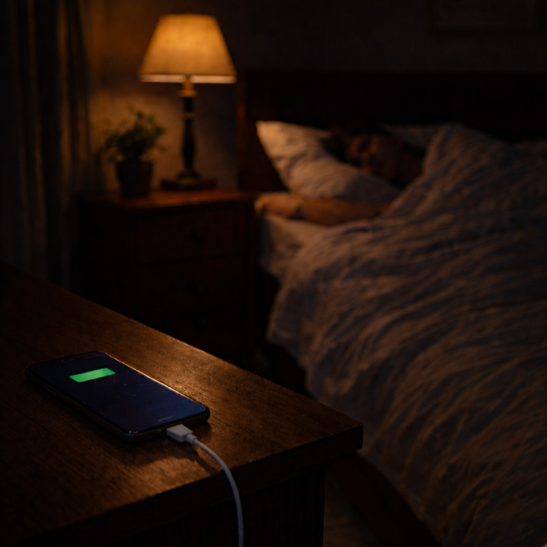
Task: Give a five-minute talk on screen time and sleep in which you
- describe, compare and contrast the pictures above.
- analyze why so many young people struggle to put their phones down at night, and what effects this has on health and wellbeing.
- discuss your own phone habits before bed and what strategies might help establish healthier routines.

Part 2 – Paired Activity
Task: Your school's health committee is launching a 'Sleep Well, Screen Off' campaign to help students develop healthier bedtime habits. You and your partner are designing the campaign.
Discuss the following campaign messages and agree on THREE to feature prominently:
- The science of blue light and how it affects sleep
- A '30-minute wind-down' challenge (no screens before bed)
- Tips for keeping your phone out of the bedroom
- Student testimonials about improved sleep after changing habits
- How sleep affects grades, mood, and athletic performance

TASK SET A2: Good Morning, Alexa

Part 1 – Individual Long Turn

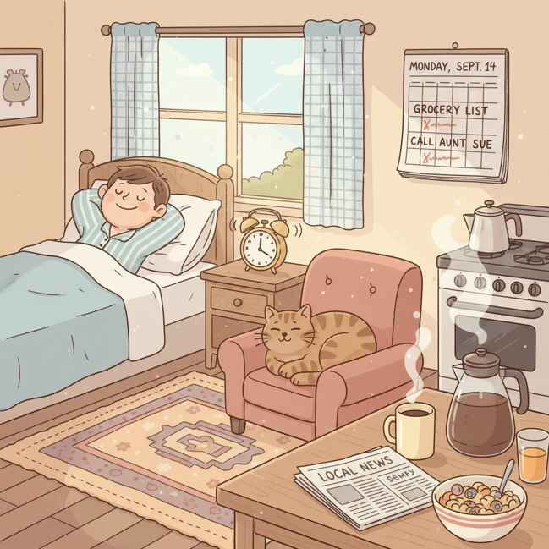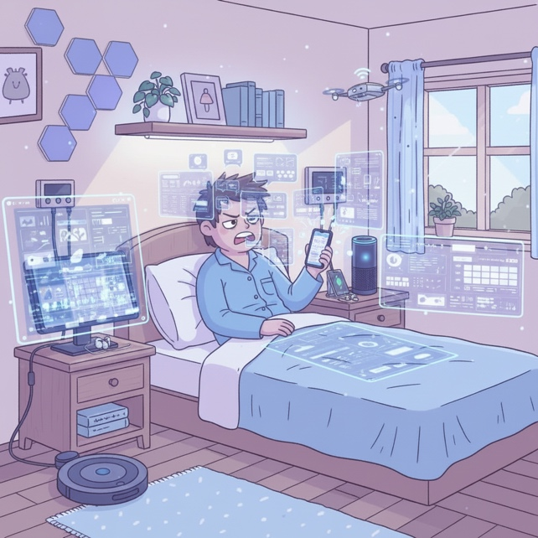
Task: Give a five-minute talk on technology in our daily lives in which you
- describe, compare and contrast the two illustrations above.
- evaluate the pros and cons of living in a 'smart home' with voice assistants and connected devices.
- discuss whether we are becoming too dependent on technology

Part 2 – Paired Activity
Task: Your school is organizing a 'Tech-Free Challenge Day' where students try to go without smartphones and smart devices for 24 hours. You and your partner are on the organizing committee.
Discuss and agree on THREE aspects to organize:
- What alternative activities to provide during the day
- How to handle emergencies without phones
- What exceptions should be allowed (medical needs, family emergencies)
- How to motivate reluctant students to participate
- How to measure and reflect on the experience afterward

TASK SET A3: The Notification Trap

Part 1 – Individual Long Turn

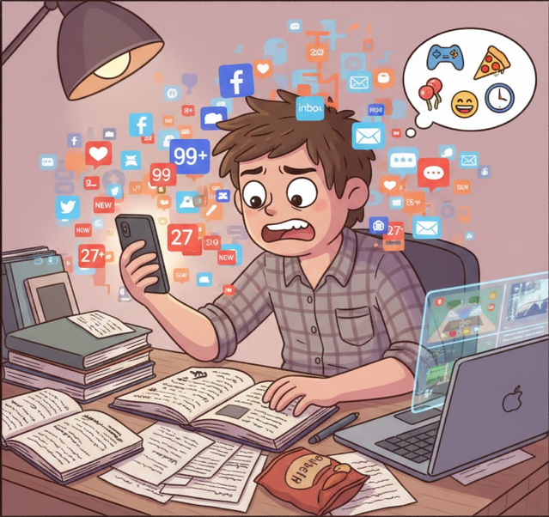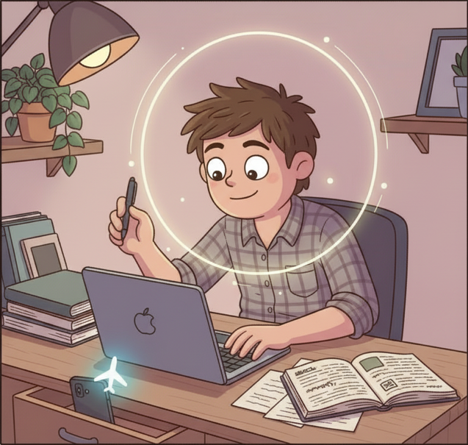
Task: Give a five-minute talk on focus and distraction in the digital age in which you
- describe, compare and contrast the two illustrations above.
- analyze why notifications are designed to capture attention.
- discuss strategies you use (or could use) to protect your focus and avoid constant interruption.

Part 2 – Paired Activity
Task: Your school is introducing 'Focus Hours' – dedicated periods during the school day when phone use is completely banned to help students concentrate. You and your partner are advising on the policy.
Discuss the following implementation ideas and agree on THREE to recommend:
- Phones collected in lockable pouches at the start of Focus Hours
- Students keep phones but must use airplane mode (trust-based)
- Phone-free zones created in specific areas (library, study hall)
- A reward system for classes that successfully complete Focus Hours
- Education sessions explaining the science of focus and distraction

CATEGORY B: QUOTES

TASK SET B1: Privacy in the Digital Age

Part 1 – Individual Long Turn
Quote 1:
"Arguing that you don't care about privacy because you have nothing to hide is no different than saying you don't care about free speech because you have nothing to say."
— Edward Snowden, Reddit AMA (May 21, 2015)
Quote 2:
"Privacy is what allows us to determine who we are and who we want to be."
— Edward Snowden, The Guardian Q&A / Christmas Message (2013)
Task: Give a five-minute talk on privacy as a fundamental right in which you
- analyze and compare the two quotes above, explaining how they present different aspects of privacy.
- evaluate the argument that 'if you have nothing to hide, you have nothing to fear.’
- discuss how much privacy you willingly give up online.

Part 2 – Paired Activity
Task: You have been invited to meet with your country's Data Protection Commissioner to discuss young people's concerns about digital privacy. Before your meeting, discuss these topics and agree on THREE to focus on:
- Social media companies collecting data on teenagers
- Schools using monitoring software on student devices
- The right to delete embarrassing content from your teenage years
- Apps that share location data without clear consent
- Whether privacy education should be mandatory in schools

TASK SET B2: Truth in the Age of Information

Part 1 – Individual Long Turn
Quote 1:
"The lowest form of popular culture – lack of information, misinformation, disinformation, and a contempt for the truth – has overrun real journalism."
— Carl Bernstein, Pulitzer Prize-winning journalist
Quote 2:
"Censorship no longer works by hiding information from you; censorship works by flooding you with immense amounts of misinformation, of irrelevant information, until you're just unable to focus."
— Yuval Noah Harari, Author of '21 Lessons for the 21st Century'
Task: Give a five-minute talk on truth and misinformation in the digital age in which you
- analyze and compare the two quotes above.
- discuss why misinformation has become a significant problem online.
- outline strategies that individuals, schools, or governments could use to combat misinformation.

Part 2 – Paired Activity
Scenario: Your school is debating the motion: 'Social media platforms should be legally responsible for the misinformation spread on their sites.' Take opposing positions and discuss the following aspects:
- Whether platforms can realistically monitor all content
- The balance between free speech and content moderation
- Who should decide what counts as 'misinformation'
- User responsibility vs. platform responsibility
- Examples of platforms that have tried and succeeded/failed

CATEGORY C: ALTERNATIVE PROMPTS

TASK SET C1: The Digital Literacy Paradox

Part 1 – Individual Long Turn
Text Extract:
THE DIGITAL LITERACY PARADOX
Young Europeans are the most connected generation in history: 97% of 16-29 year-olds use the internet daily. Yet only 36% verify the truthfulness of information they find online. Despite growing up with technology, 43% of 14-year-olds do not reach basic digital skills levels. Meanwhile, 76% of young Europeans report encountering fake news at least once in the past week. This creates a troubling gap: technical access to information far outpaces the critical thinking skills needed to evaluate it.
Sources: Eurostat (2023-2024), Eurobarometer (2024), ICILS (2023), Euronews Youth Survey (2025)
Task: Give a five-minute talk on digital literacy among young people in which you
- explain the 'digital literacy paradox' described in the text and why it is concerning.
- analyze why technical skills do not equal critical information literacy.
- suggest how schools could better prepare students to navigate misinformation.

Part 2 – Paired Activity
Scenario: Your school is introducing a 'Digital Literacy Week' with workshops for all students. You and your partner are helping to select the workshop topics.
Task: Discuss the following workshop ideas and agree on THREE to include:
- 'Spot the Fake': Identifying manipulated images and deepfakes
- 'Source Check': How to verify news articles and websites
- 'Algorithm Awareness': How social media decides what you see
- 'Fact vs. Opinion': Distinguishing between reporting and commentary
- 'AI and Information': How AI generates and detects fake content

TASK SET C2: Where Does the Time Go?

Part 1 – Individual Long Turn

Statistical Data

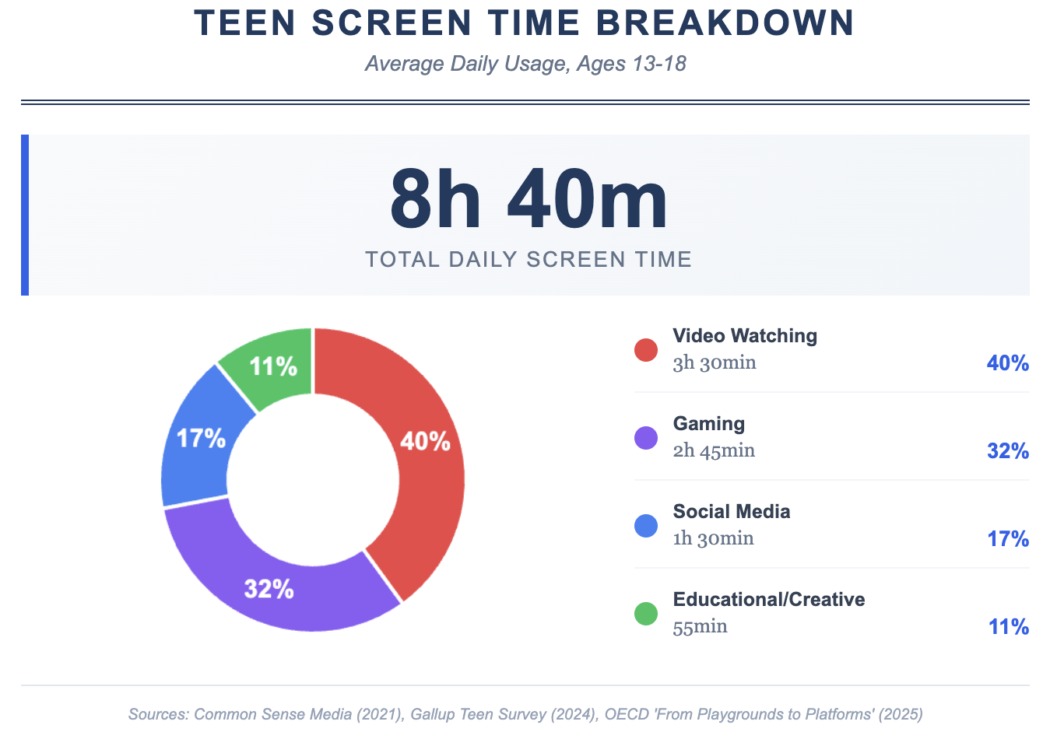

Task: Give a five-minute talk on teen screen time habits in which you
- describe what the data reveals about how teenagers spend their screen time.
- evaluate whether this distribution is healthy and its consequences.
- discuss your own screen habits and whether you think they are balanced.

Part 2 – Paired Activity
Scenario: You are working with a digital wellbeing expert to develop recommendations for teenagers about healthy screen habits.
Task: Discuss the following recommendations and agree on THREE to include in your final advice:
- Setting app time limits and using screen time tracking
- Creating 'phone-free zones' (bedroom, dinner table)
- Scheduling regular 'digital detox' periods
- Shifting from passive to active screen use (creating vs. consuming)
- Using grayscale mode to reduce phone attractiveness

